`

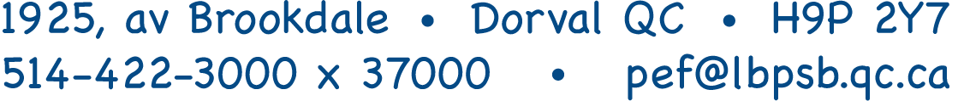

Grants to Schools and Classrooms 2019-2020 Application
DEADLINE FOR COMPLETE SUBMISSION: October 31, 2019
PLEASE NOTE, THIS DEADLINE MUST BE RESPECTED.

Please Read and follow all instructions:
All accompanying documents must be attached at the time of submission.
Email the request which you have saved as a PDF, by October 31, 2019 to pef@lbpsb.qc.ca
No faxes. Only electronic versions of the grant request should be sent. Receipt will be confirmed.

Send by email only: Completed grant proposal in PDF format
Cost budget including prices, tax, shipping (supplier quotes are appreciated)
Minutes or draft minutes of governing board resolution showing approval for proposal

Signature page to be received by internal mail within a week

Late requests & those missing parts may be considered for the 2020-2021 year.

If you need any information, please contact the PEF office well before the deadline to avoid disappointment & delays.
514-422-3000 ext 37000, pef@lbpsb.qc.ca

The PEF Grants to Schools & Classrooms Program will fund the material supplies for innovative, sustainable projects, which engage students in hands-on learning, fulfill one or more requirements of the LBPSB Strategic Plan, and which are not funded through the MELS parameters.
Grant funding does not cover field trips, facilitators/performers, capital improvements to the building, or most consumable or one use items.
PEF will not pay for supplies already purchased.
Decisions regarding the awards will be rendered by the PEF Board of Directors in Mid-February, at which time you will be advised of the procedure to follow in receiving your requested merchandise.

Date of Submission:
School/Centre/Other:
Title of Proposal:
Project Contact Person:
Email & Telephone of Contact person:
If more than 1 application per school, you must prioritize. (e.g.,1 of 2)
Other key persons involved:
Name: |  | Role:
Name of approving administrator:
Describe the project, including intended objectives, expected outcome: expand/attach pages as needed.

What grades, number of students will be impacted by the project:
Number of students in your school:
How will this project be sustained after the school year? What equipment/supplies will be available for future students?
How will the value of the project to the students’ success and to LBPSB Strategic Plan be evaluated?
Specific Budget:
Item(s) you are requesting:
Cost of each item including fees & taxes. You must do the research & attach proof of costs. |  | $
Total cost of the project: |  | $
Funding obtained from other sources: |  | $
Please specify sources of other funding:
Amount Requested from PEF: (maximum $3,000) |  | $
Signature page of grant request from: (Name of School)

This is the only page we require in hard copy. All other pages of your document should have been emailed by the deadline.

Title of Proposal:
Consultative groups approving the project (signature required) see below:
Governing Board chair:

IMPORTANT: Copy of Governing Board Resolution approving project was attached at the time of submission.
Principal:
Staff Council Chair:

